**Floating Wooden Corner Shelves**

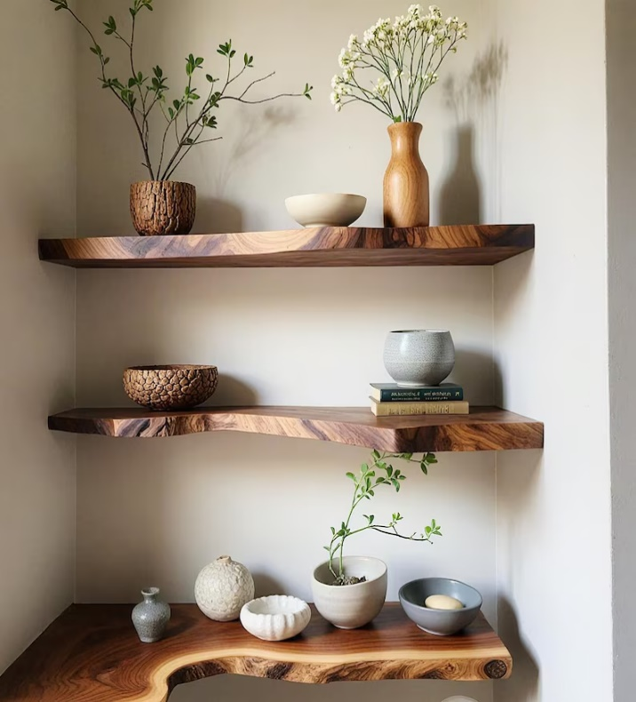Floating Wooden Corner Shelves are a stylish and practical way to maximize corner spaces in any room. Crafted from high-quality wood, these shelves offer a natural, rustic charm while maintaining a sleek, minimalist design. The floating structure creates an elegant look, as the shelves seem to "float" on the wall without visible brackets, providing a clean and unobtrusive storage solution. Perfect for displaying books, plants, photos, or decor, these shelves are ideal for living rooms, bedrooms, kitchens, or offices. Their versatility and solid wood construction make them both functional and durable, adding a warm, inviting touch to any space.

.

.